The laboratory work 14

Exercise 1: Read sales data of bathing soap of all months and show it using a bar chart. Save this plot to your hard disk

The bar chart should look like this.

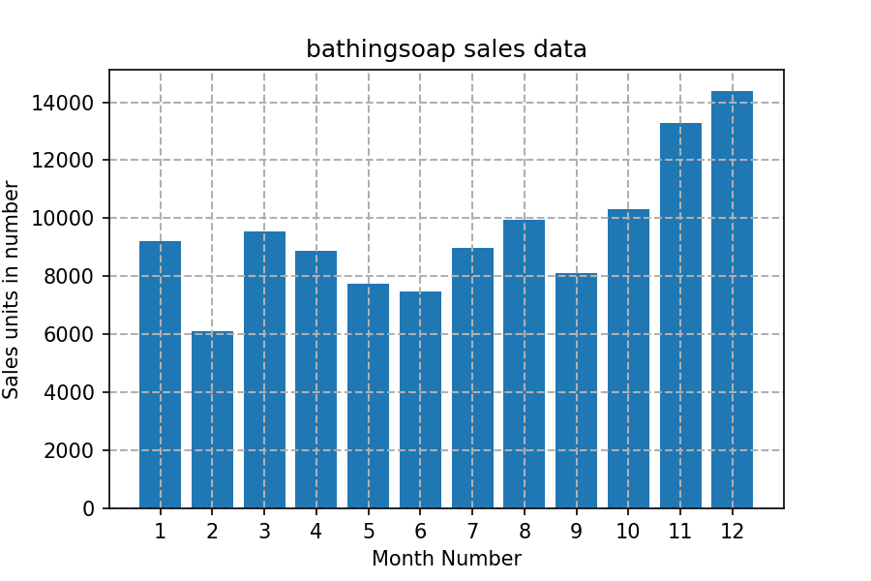

Exercise 2: Read the total profit of each month and show it using the histogram to see the most common profit ranges

The histogram should look like this.

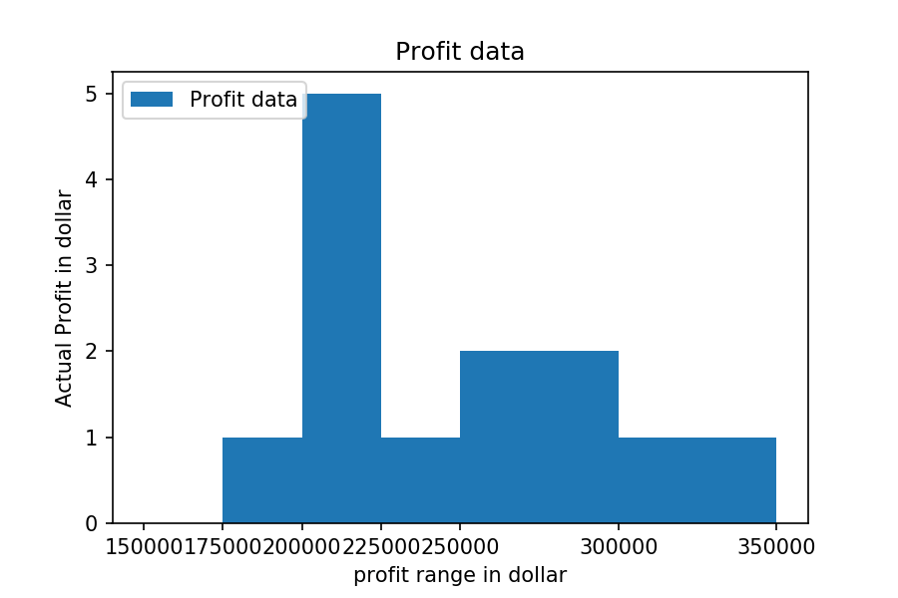

Exercise 3: Calculate total sale data for last year for each product and show it using a Pie chart
Note: In Pie chart display Number of units sold per year for each product in percentage.
The Pie chart should look like this.

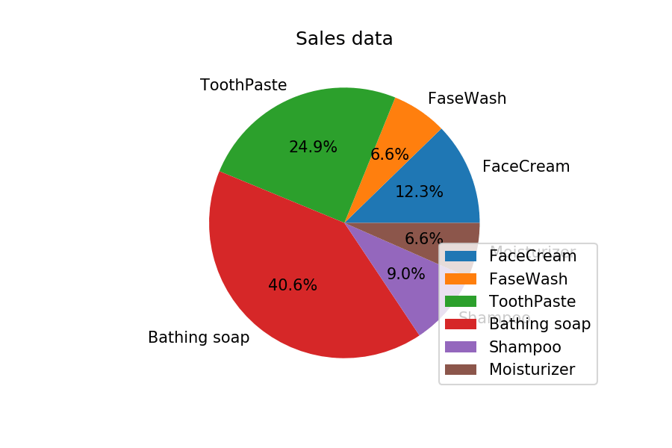

Exercise 4: Read Bathing soap facewash of all months and display it using the Subplot

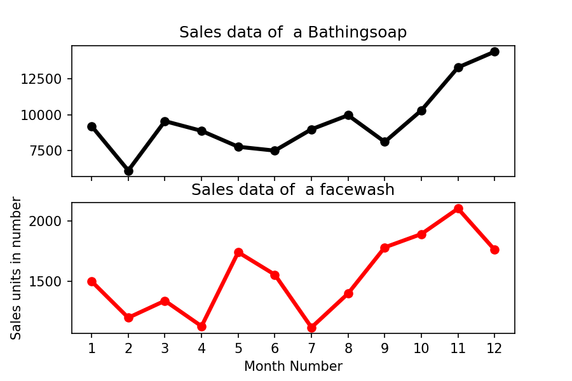

Exercise 5: Read all product sales data and show it using the stack plot

